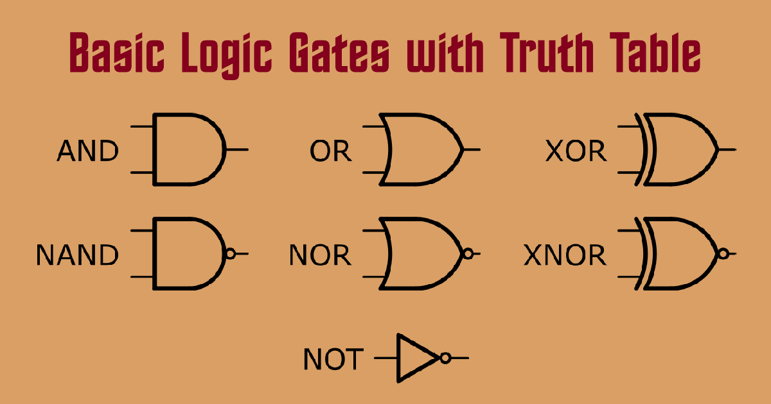
Logic Gates
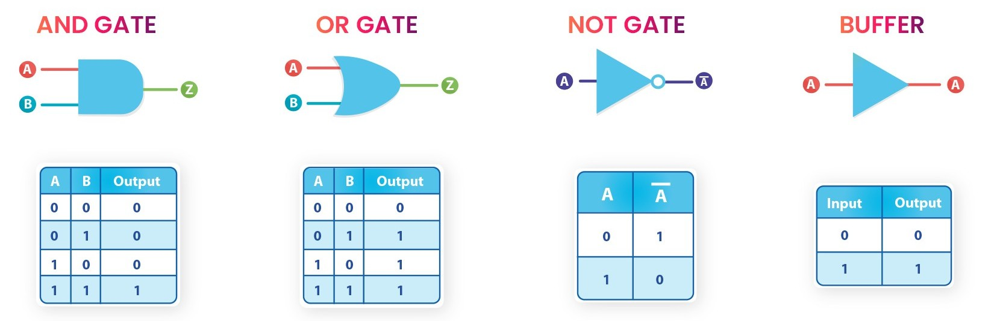
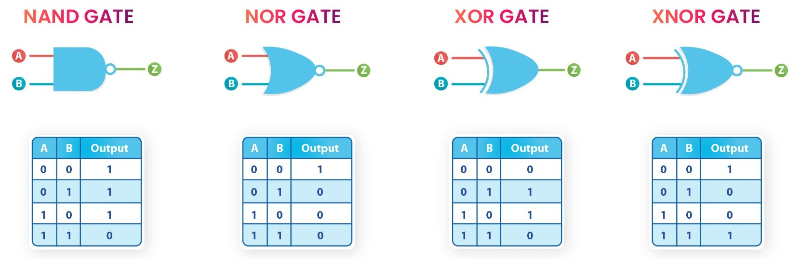
- XOR & XNOR Equations :

- XOR gate :-
Y = A ⊕ B
Y = A’B + AB’

- XNOR gate :- XNOR = XOR + NOT
Y = A ⊙ B
Y = AB + A’B’
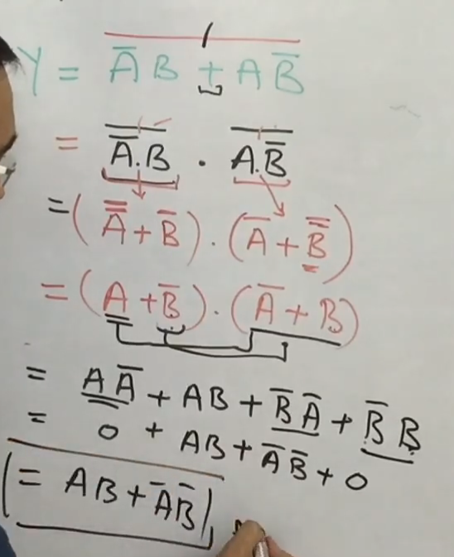

- NAND as Universal Gate :-

- NOT Gate :-
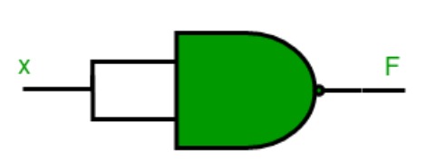
- AND Gate (2 Gates):- Complement of NAND Gate
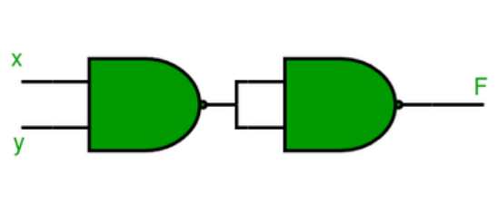

- OR Gate (3 Gates) :-
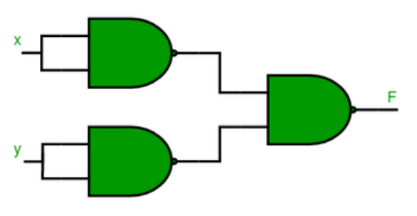
- NOR Gate (4 Gates):- OR Gate + NOT Gate
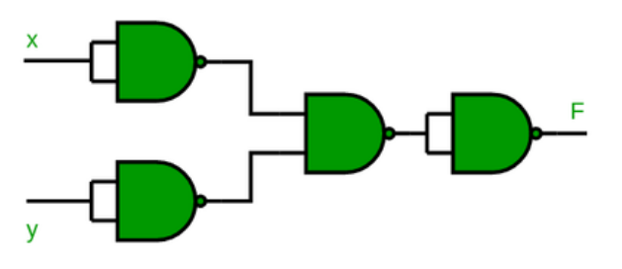
- XOR Gate (4 Gates):-

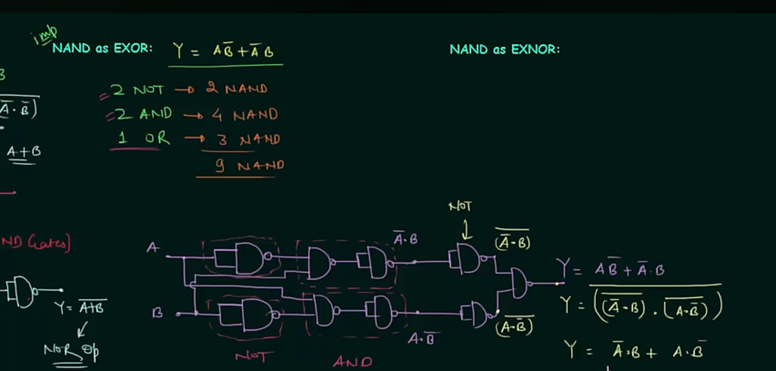

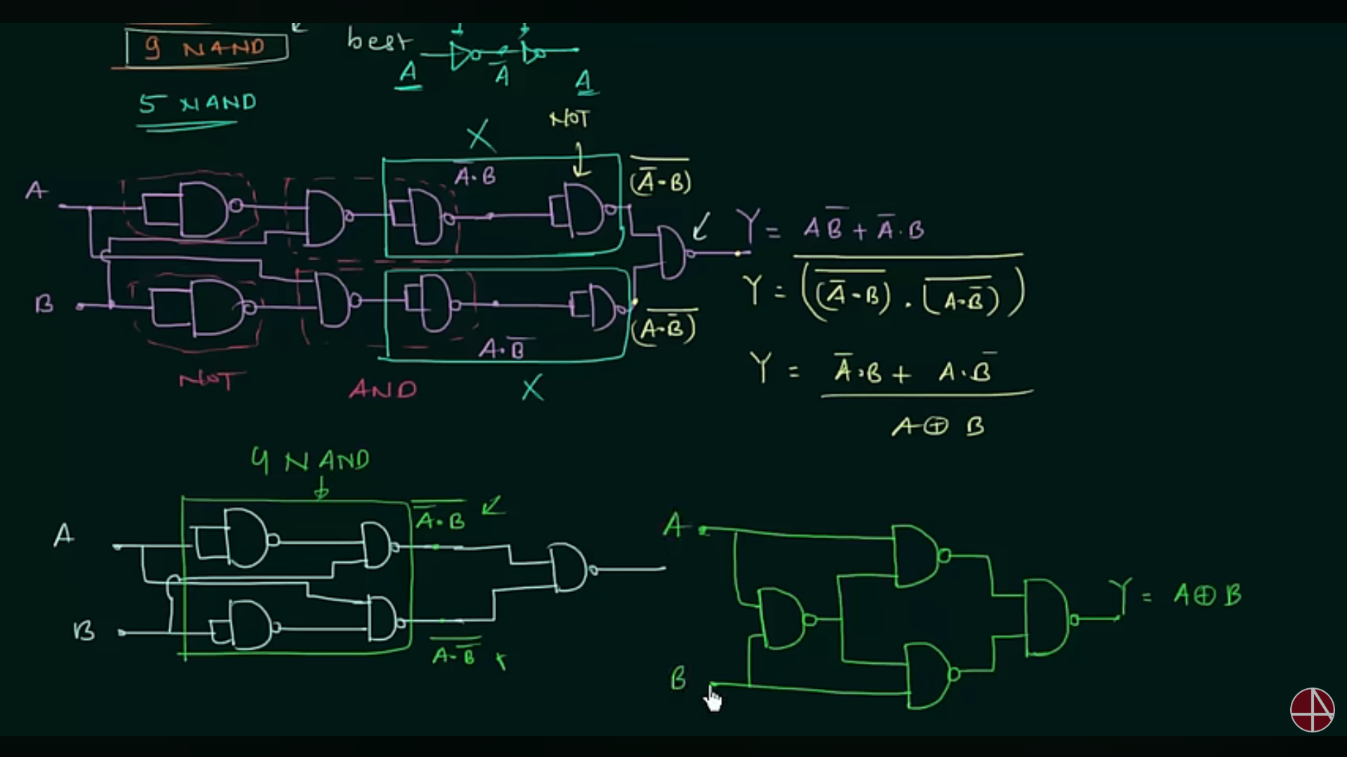

- Final Circuit for XOR using NAND :-

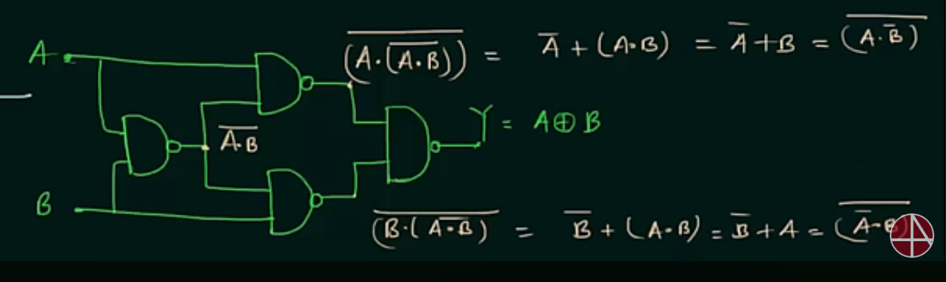

- XNOR Gate (5 Gates):- XOR + NOT
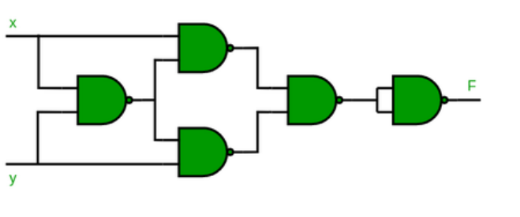
- Q.1 :-
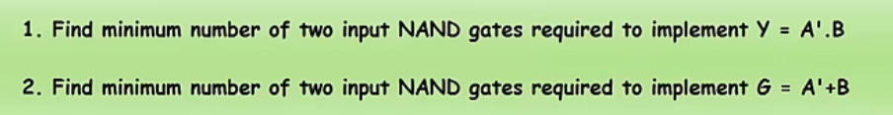

- Q.2 :-
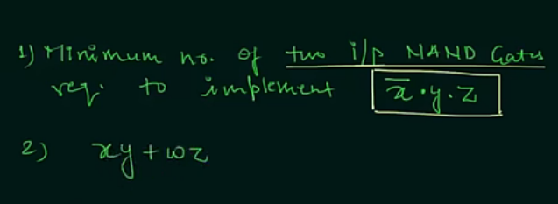

- NOR as Universal Gate :-
- NOT Gate :-
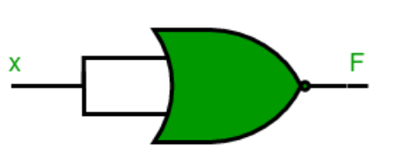
- OR Gate (2 Gates):- NOR + NOT
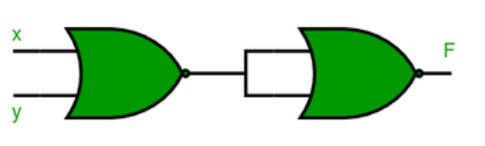
- AND Gate (3 Gates) :-
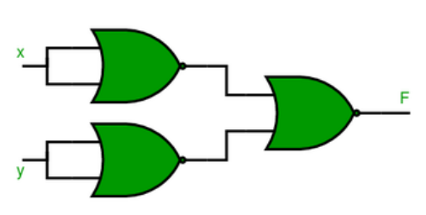
- NAND Gate (4 Gates) :-
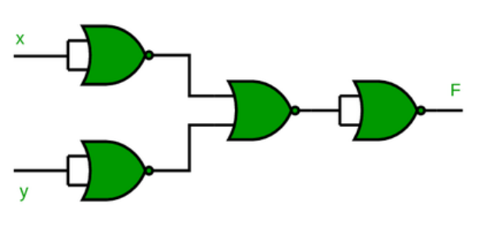
- XOR Gate (4 Gates) :-
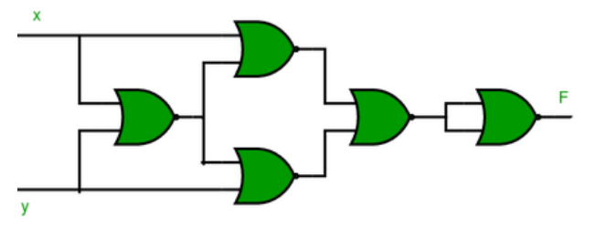
- XNOR Gate () :-
